**WORKSHOP**

**(GUI Application)**

**Exercise 1:** Design form as follows:



**Requirement:**

* When click **RESET** button, set emty value for TextFields.
* When click **EXIT** button, close the program (show confirm dialog before).
* When open the window form, **RESET** and **OK** buttons disabled.
* When one of the values of two TextFields is not empty, **RESET** button is enabled, otherwise disabled
* When both of the values of two TextFields are not empty, **OK** button is enabled. Otherwise **OK** button is disabled.
* When click **OK** button:

+ Check input: Integer type for a and b.

+ Depending on which RadioButton option, perform processing and display result in Label **Hien thi ket qua**.

**Exercise 2:** Design form as follows:



**Requirement:**

* When click **RESET** button, set emty value for TextFields.
* When click **EXIT** button, close the program (show confirm dialog before)..
* When open the window form:

+ TextField is ReadOnly.

+ **RESET** and **V** buttons disabled.

* When one of the values of two TextFields is not empty, **RESET** button is enabled, otherwise disabled
* When both of the values of two TextFields are not empty, **V** button is enabled. Otherwise **V** button is disabled.
* When click **V** button:

+ Check input for TextField: Integer type for n, real type for x.

+ Calculate the value of the expression **S** and display it down to the TextField **Kết quả**.

**\* *Note*: Do the same above for Lesson2_1, Lesson2_2, Lesson2_3 (Exercises_reviewJava_EN)**

* ***Lesson2_1:*** Given an array of natural numbers, write a program that arranges this array in descending order.
* ***Lesson2_2*** : Given an array of natural numbers, print out the screen all prime numbers of this array.
* ***Lesson 2_3:*** Given an array of natural numbers, find and print a min (max) value of this array and all indices that correspond to this min (max) value.

**Exercise 3**: Design form as follows:

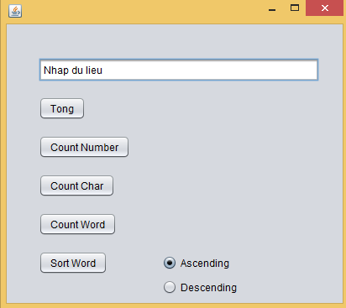

TextField named **txtInput**

**Requirement:**

a. When click **Tong** button, show MessageBox the sum of the numbers in the **txtInput**.

b. When click **Count Number** button, the screen displays the number of the characters as a number.

c. When click **Count Char** button, the screen displays the sum of the charactes in **txtInput**, but not space.

d. When click **Count Word** button, the screen displays the sum of the word in **txtInput**.

e. When click **Sort Word** button, sort all of the words in **txtInput** in ascending or descending order, completely depending on the choice of Ascending or Descending option.

**\* *Note*: Do the same above for Lesson4_1, Lesson4_2, Lesson4_3, Lesson4_4, Lesson4_5, Lesson4_6, Lesson4_7, Lesson4_8 (Exercises_reviewJava_EN)**